Task 4: Power BI Traffic Intelligence Dashboard
Import the traffic CSV file into Power BI Desktop and use Power Query Editor to prepare the data.
4.1 Data quality and preparation
Perform the following:
- Determine the number of rows and columns.
- Identify null/missing values and the columns affected.
- Check whether the data types are appropriate.
- Extract Hour from DateTime.
- Create Temperature in Celsius.
- Create a Traffic Category:
Traffic Volume | Category
< 4,500 | Low
4,500–5,500 | Medium
> 5,500 | High

Data checks done:
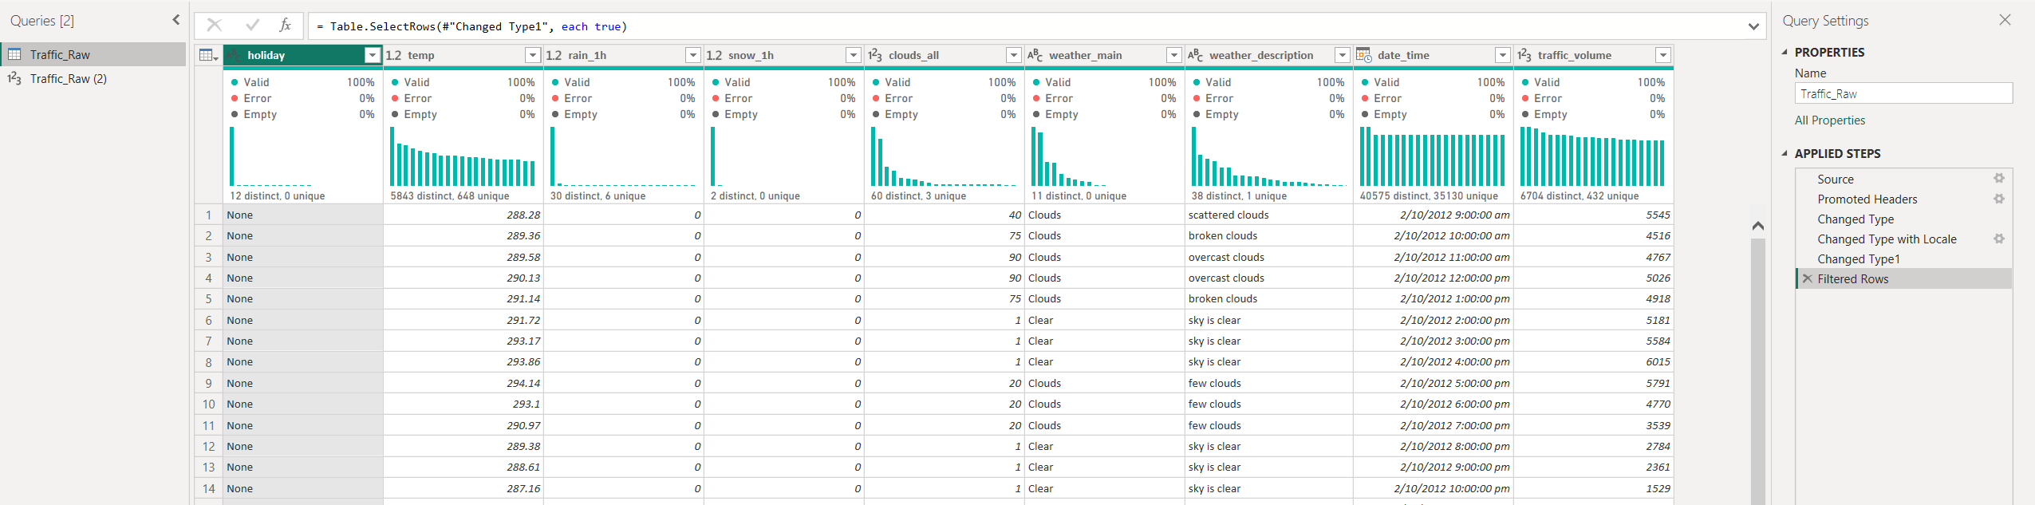
Used a reference table for row counts as:
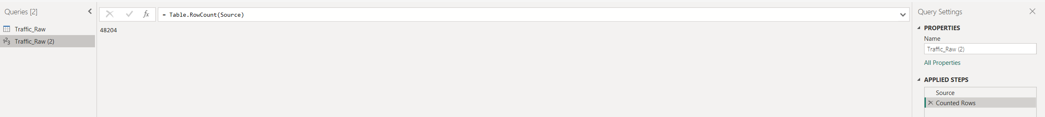
Duplicate hours: 7,629 extra rows (40,575 distinct hours) seen from column header.
rain_1h: One extreme value, 9,831.3 mm noticed from column header

4.2 Dashboard analysis
Create visualisations showing:
A. Daily traffic trends
- Show daily average traffic trends for 2015, 2016 and 2017.
B. Hourly traffic patterns
- Create a column chart showing average traffic by hour for 2017.
C. Weather impact
Analyse average traffic by weather condition and answer:
- Which weather condition has the highest average traffic?
- Which has the lowest?
- What is the difference between the highest and lowest average traffic?
D. Temperature and traffic
Create a scatter plot of:
- Temperature vs. traffic volume.
Discuss:
- Whether a visible relationship exists.
- The temperature range associated with higher traffic.
- Any notable outliers.

Power BI Dashboard created for this:
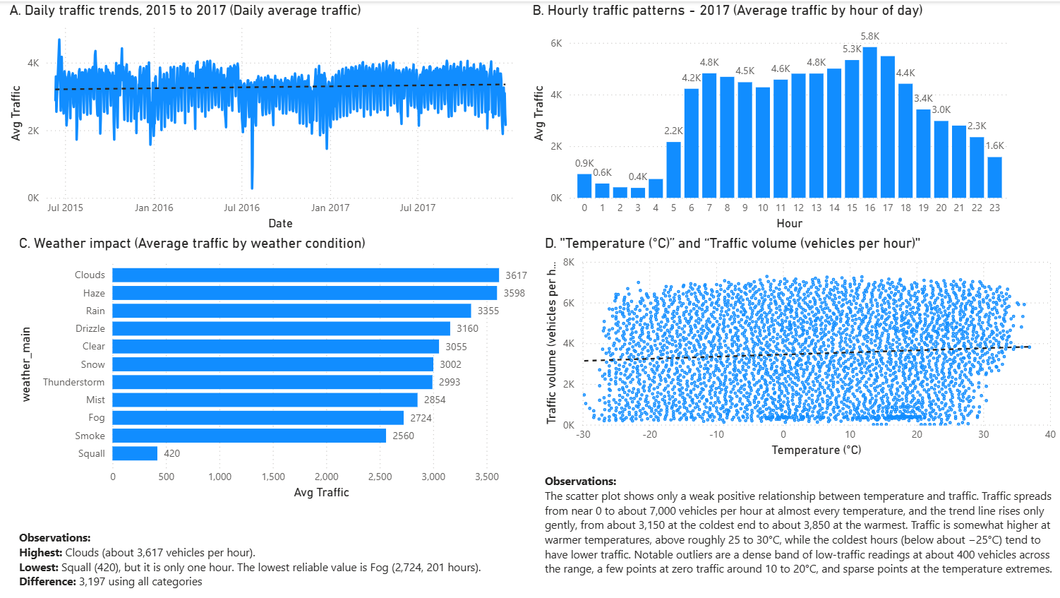

C.
Which weather condition has the highest average traffic?
Clouds, at about 3,617 vehicles per hour. It is also the most reliable result, because it rests on 15,123 hours. Haze (3,598) is almost level with it.
Which has the lowest?
Squall, at 420 vehicles per hour. That value comes from a single hour, so it is not reliable. Smoke (2,560) rests on only 15 hours. Among conditions with enough data, the lowest is Fog, at about 2,724 vehicles per hour (201 hours).
What is the difference between the highest and lowest average traffic?
- Using all categories: 3,617 − 420 = 3,197 vehicles per hour.

D.
Is there a visible relationship?
Only a weak positive one.
- The points form a wide, even cloud from about −30°C to 37°C, and traffic ranges from near 0 to about 7,000 vehicles per hour at almost every temperature.
- The dashed trend line slopes gently upward, from about 3,150 vehicles at the coldest end to about 3,850 at the warmest end. The rise is small compared with the vertical spread of the points.
- Points above 6,000 appear at nearly every temperature from about −25°C to 33°C, so high traffic is not limited to warm hours. Temperature alone does not predict how busy the road will be.
Temperature range associated with higher traffic
- The trend line is highest at the warm end of the chart, above roughly 25 to 30°C, and lowest at the cold end.
- The very coldest points (below about −25°C) mostly sit below about 2,000 vehicles, which is lower than the rest of the cloud.
- The scatter alone can’t give exact averages for each temperature band, so any figure here is only indicative.
Notable outliers
- A dense band near the bottom: a concentrated line of points at roughly 300 to 500 vehicles, strongest between about 5°C and 20°C. These are the low-traffic hours that occur at every temperature.
- Points at zero: a few points sit at or very close to 0 vehicles, around 10 to 20°C. These stand out from the rest of the cloud.
- Sparse points at the extremes:
  - On the left (about −30 to −27°C) there are only a few points, with low traffic of roughly 1,000 to 1,500.
  - On the right (about 35 to 37°C) there are only a handful of points, with traffic between about 3,800 and 5,900.
- Thin ends: because the edges have so few points, the trend line is less reliable there.

4.3 KPI cards and filters
Create KPI cards showing:
- Total hours analysed
- Average traffic volume
- Average temperature
Add slicers for:
- Hour range
- Weather condition
- Traffic category

Power BI Dashboard created:


